ROSHAAN TARIQ KHAN 19781

DATA: OLX USED CARS

Data wrangling steps:

* Had to change car conditions where KM driven= 1 , car was considered New else, Used
* Renamed columns to appropriate ones
* removed null rows as adding mode / median would make sales inconsistent

Paper charts:

* Following are the potential charts that can be added to describe the data
* These charts may or may not be used .They can be changed as the charts are made in the visualisation tool.

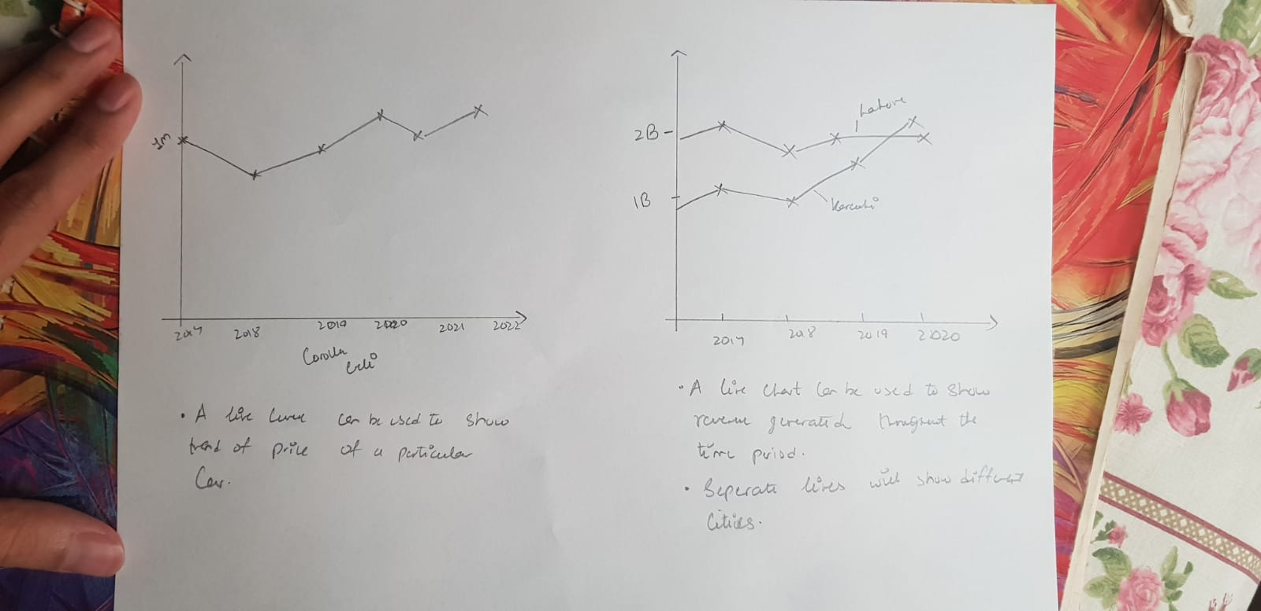

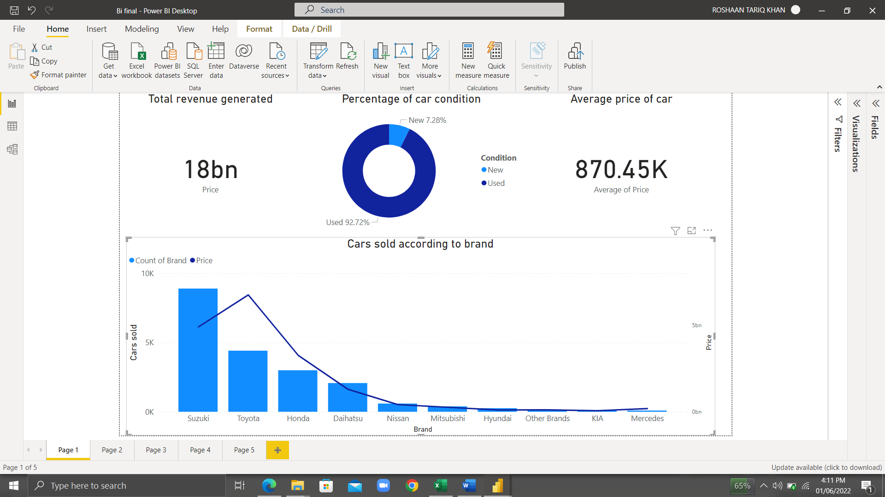**Chart analysis:**

* So my problem statement asked the question that , Does brand affect the frequency of their respective cars being purchased?, judging by the line and stacked column chart we can see that popular brands of Pakistan like Suzuki , Toyota, Honda do indeed affect the frequency of their cars being sold. This means that brand trust is at play here and customers were most comfortable buying the popular brand of car.
* The two scorecards show the overall revenue generated by olx during the time period as well as the average price of a car
* 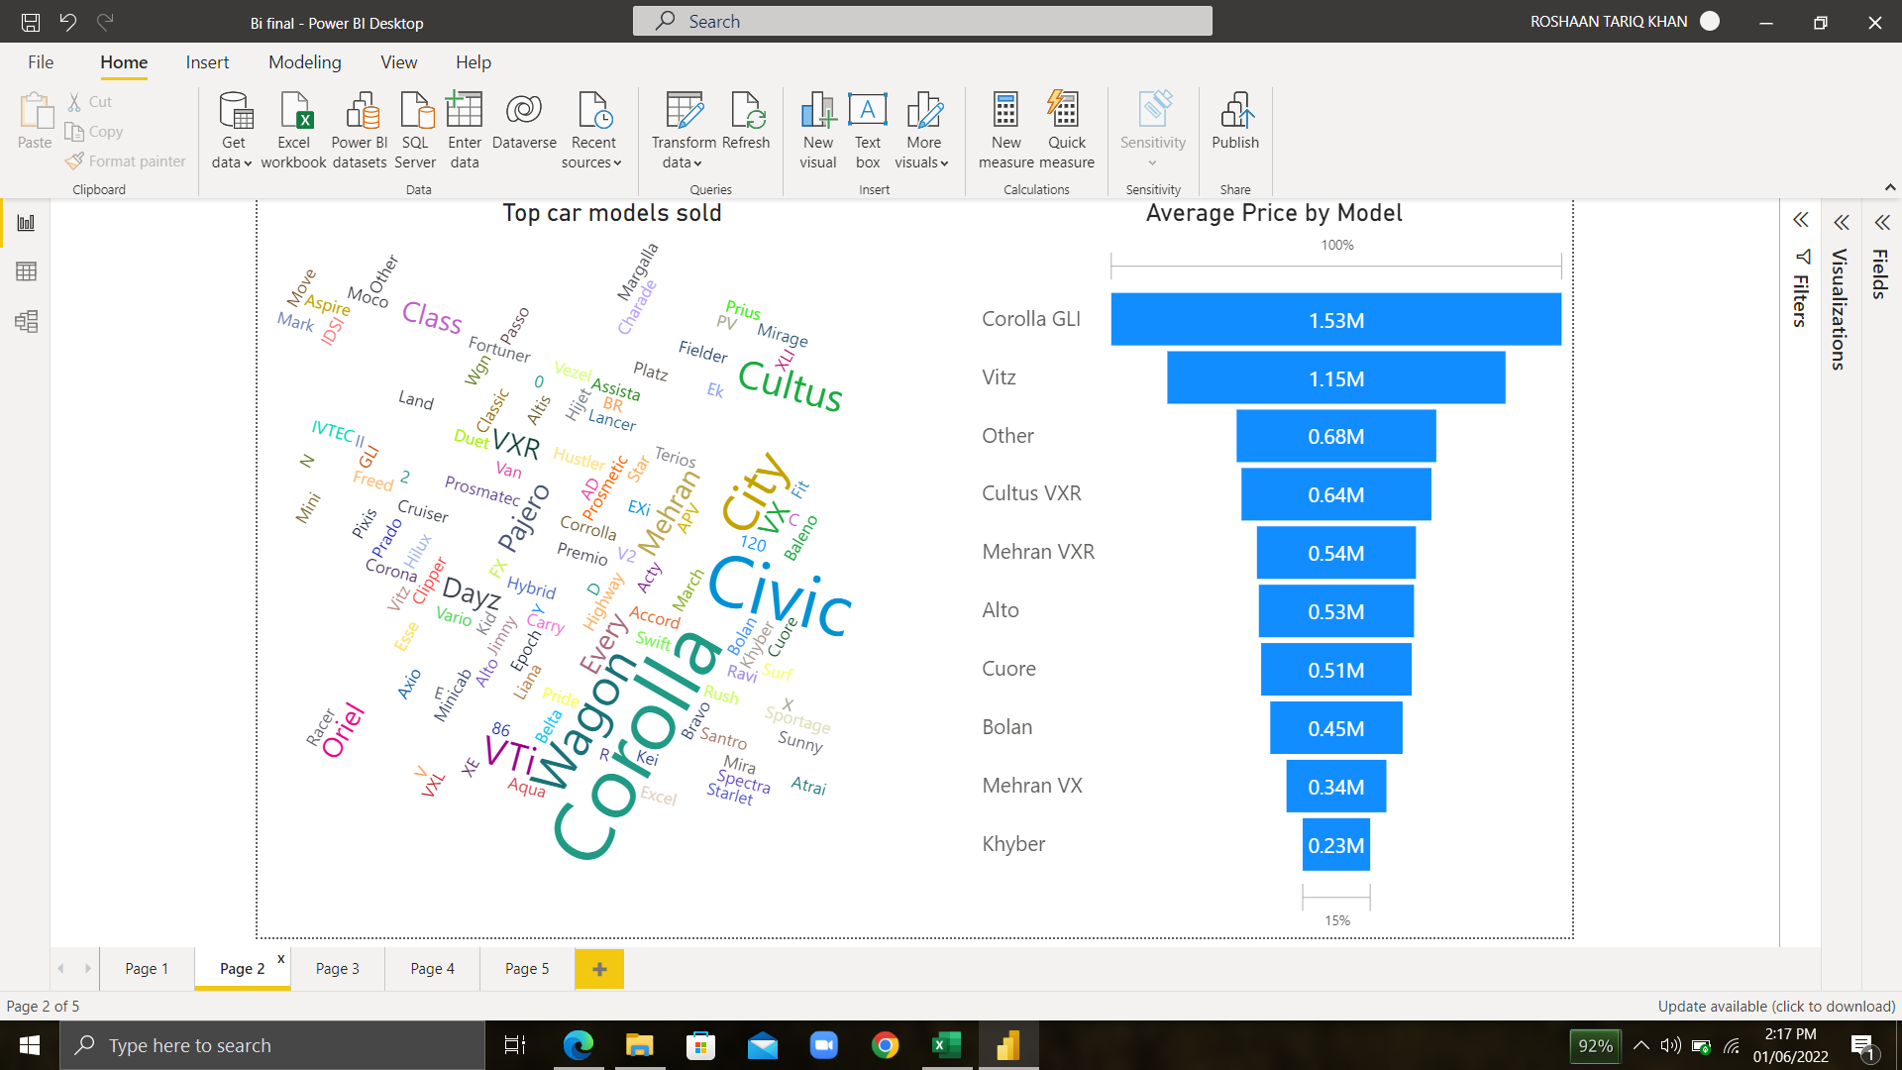Finally the donut chart shows that the customers preferred used cars over new ones , the used percentage is a whopping 92% compared to new condition. Keeping business knowledge in check, a used car is more worth the money from a long-time perspective as well as the customer knows what he’s getting compared to a new vehicle which might have unseen problems.
* As expected , the word cloud shows car models such as “Corolla” , “Civic” and “wagon” highlighted as these brands are the most popular and trusted ones in the market as seen in the previous graph ( Toyota, Suzuki).
* The funnel chart gives an overview of the average price of the specific , popular car models in the olx market.
* 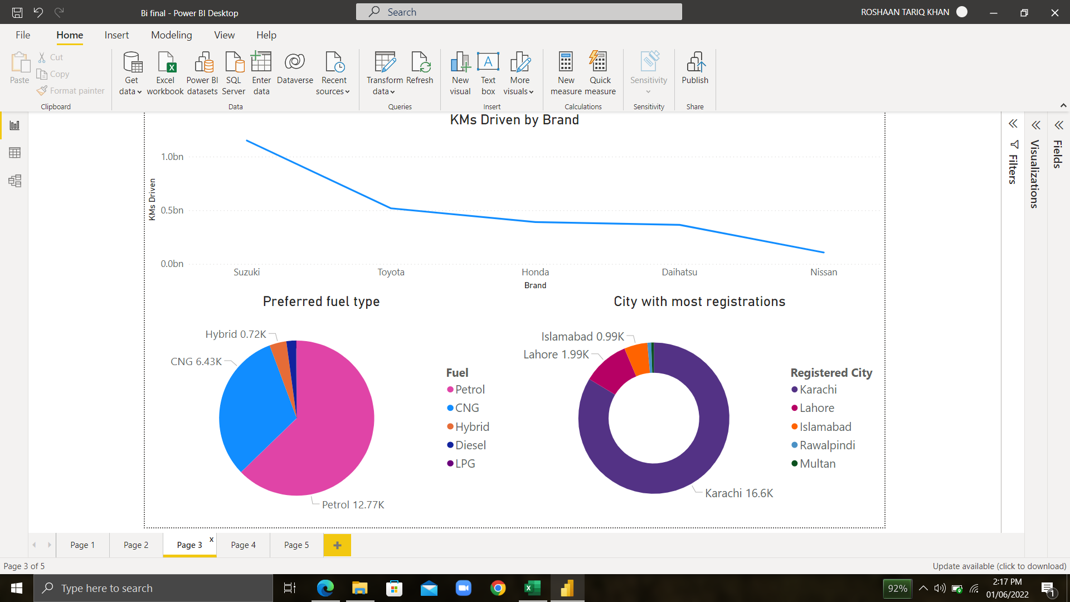The line curve at the top shows KM driven by brand which again means that the customers bought the popular brands , Suzuki,Toyota and Honda due to which the overall KM driven is the most . This also means that Suzuki one of the leading, if not the leading car brand in Pakistan.
* The pie chart shows that petrol is preferred as fuel for their vehicles
* The donut chart shows that Karachi is the leading city for registrations means most customers are from here as well since it is the largest and most populous metropolitan city in Pakistan. The car market is better off targetting and advertising in Karachi .
* 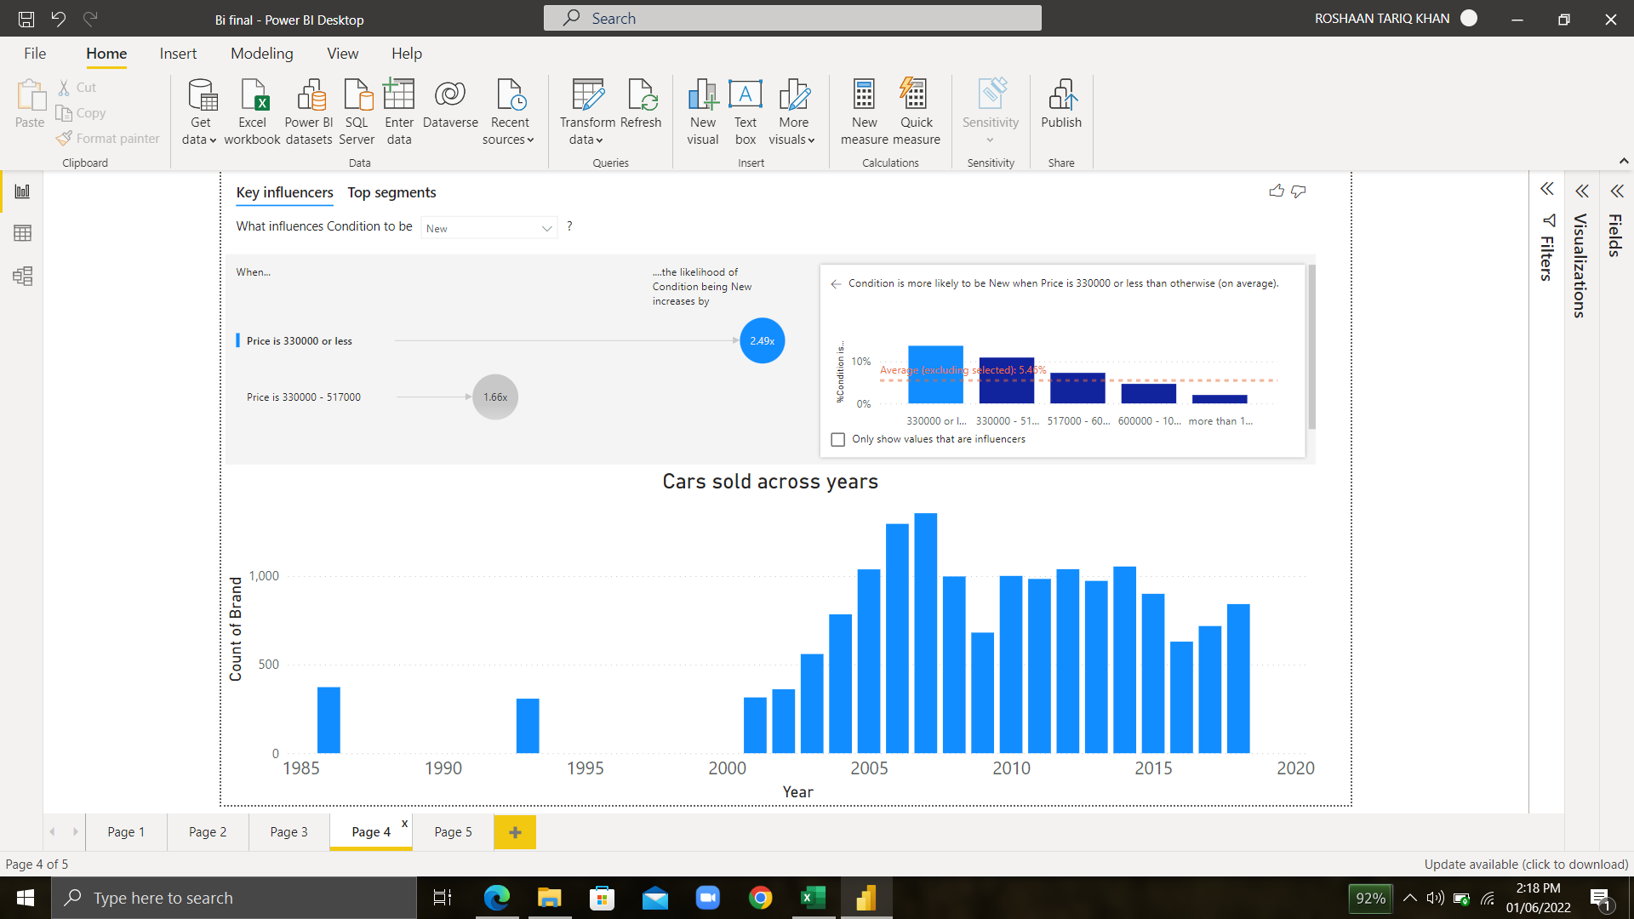The clustered column chart indicated that most of the sales were in the year 2007, and has been going through similar trends ever since. One reason could be that people are better off financially after the year 2000 than they were in the 1900s.
* An interesting finding by the key influencers graph shows that if the car is priced below 330000 , the likelyhood of it being new increases by 2.4% which means that customers who are willing to pay more for a more expensive ride would rather go for a used ride instead as the percentage goes down to 1.66%.
* 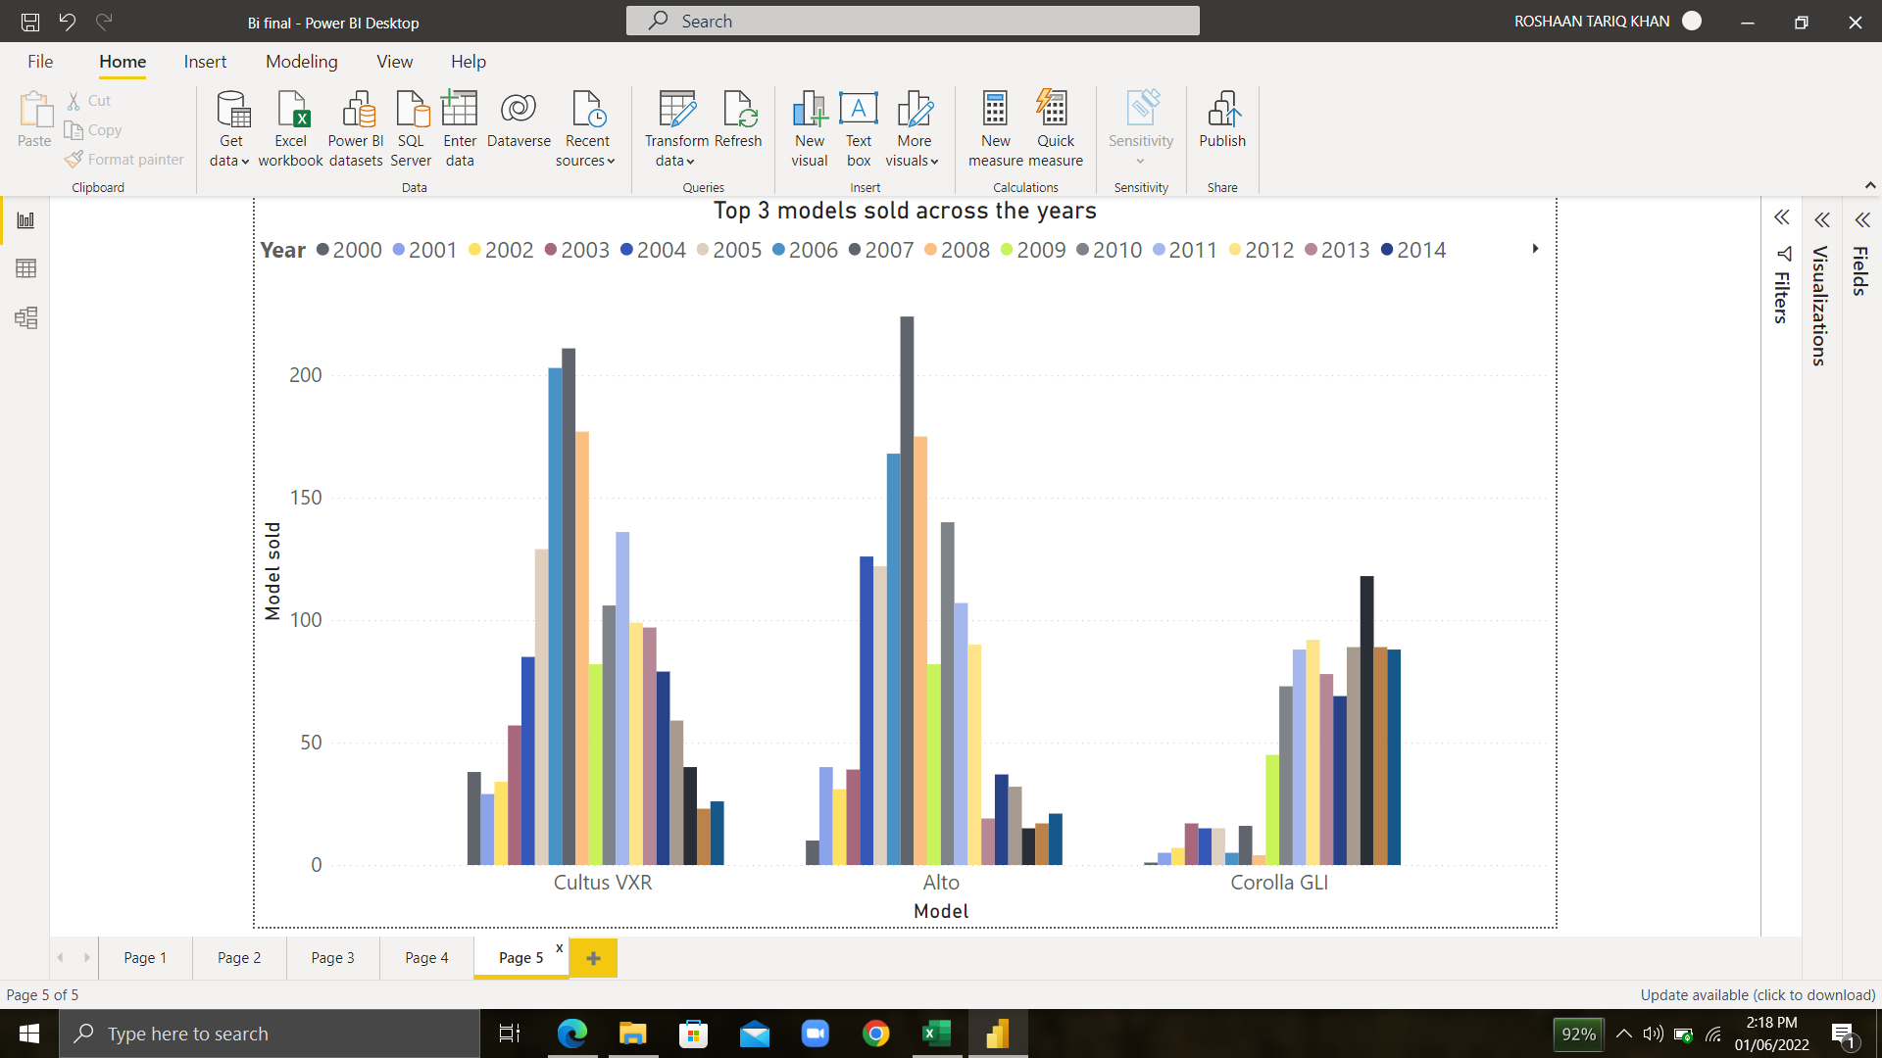My second problem statement asked the question that which car model was most popular through out the years? The chart shows that Cultus VXR , Alto and Corolla GLI were the leading car models bought during the span of 2000-2014.